|  |  |
| --- | --- |
| Name : Jabonillo, Darrel S. | Section : BSIT 3C |
| Assignment No : 3 | Submission Date : April 6, 2024 |
| Assignment Title: Guessing Game | |

**Code :**

**HTML and JS FILE**

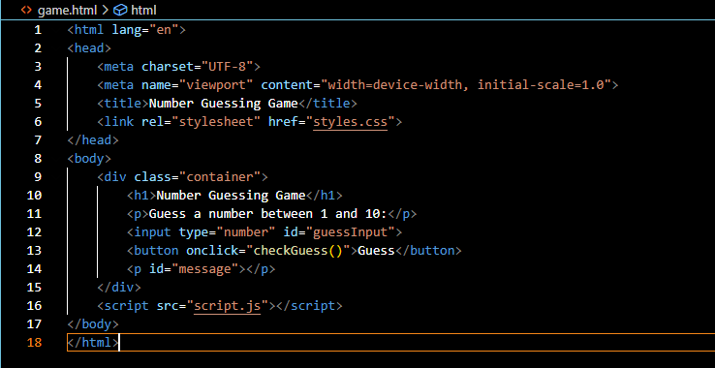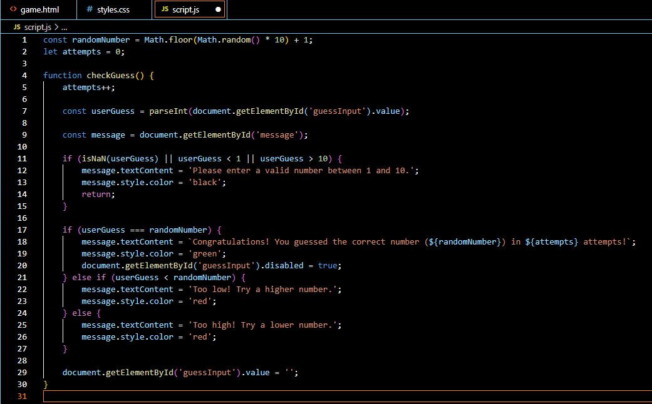

**CSS FILE**

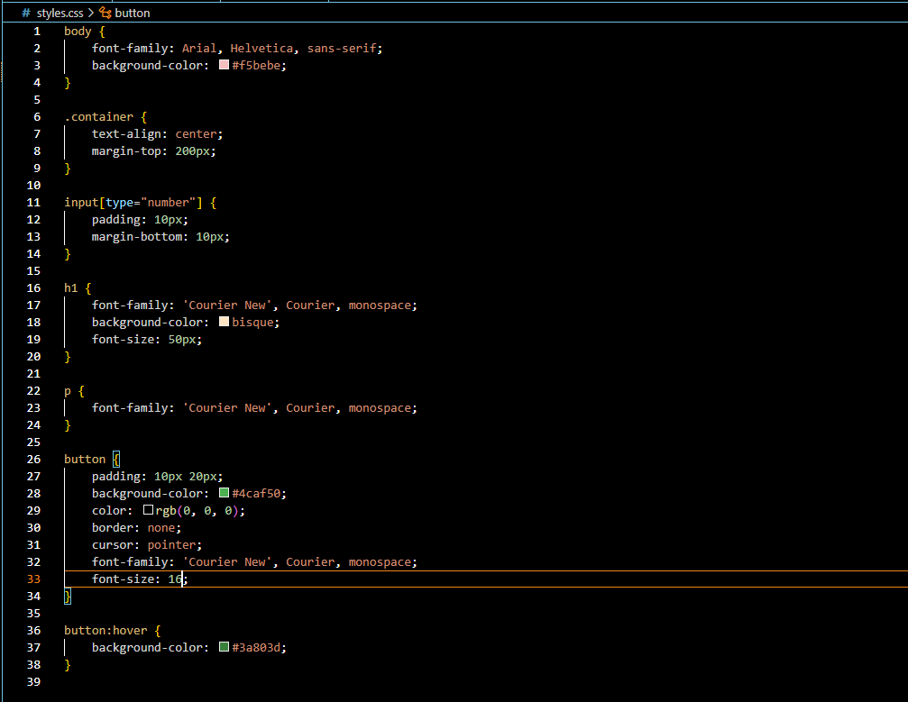

**SCREENSHOT**

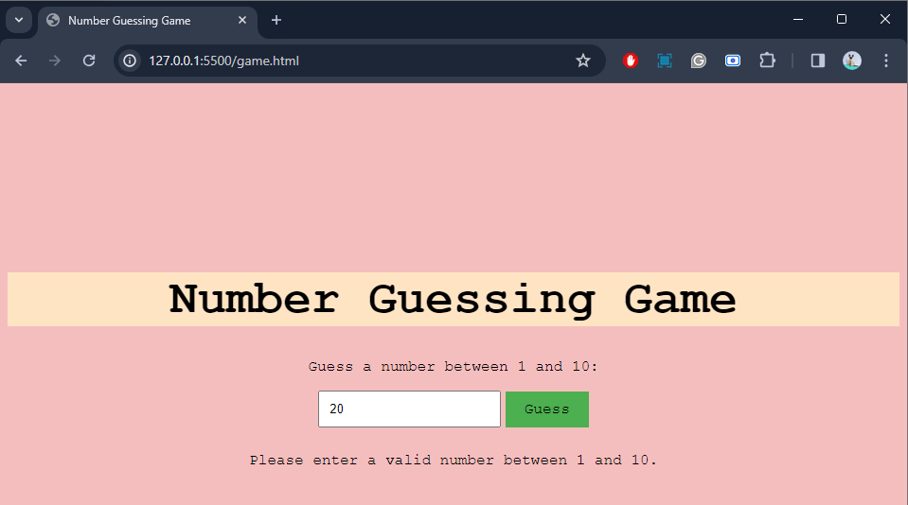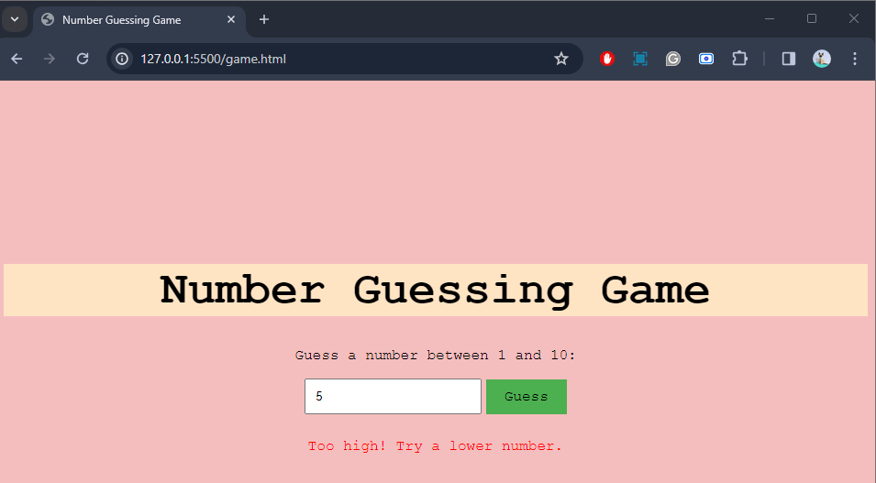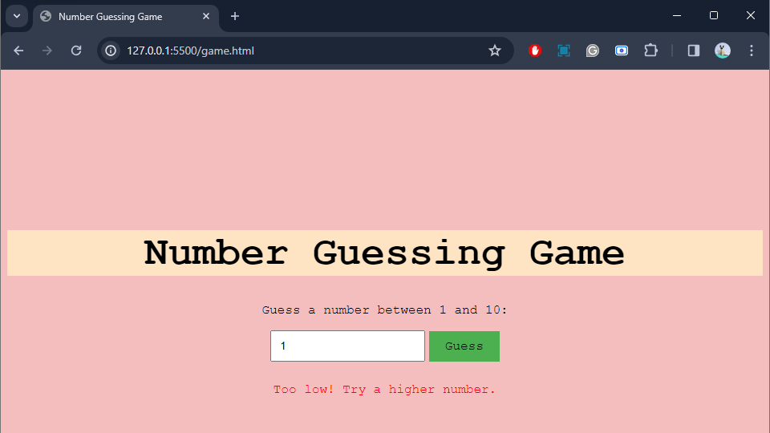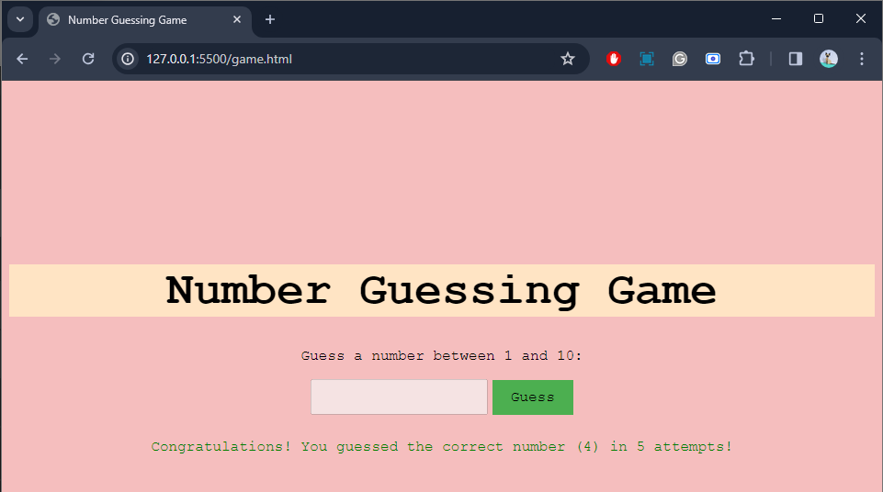

**Dictionary:**

**parseInt** - parses a string argument and returns an integer of the specified radix

**const** - a keyword that defines a variable or pointer as unchangeable.

**textContent** - property of the Node interface represents the text content of the node and its descendants.

**document.getElementById** - Returns a HTMLCollection of the elements in the object on which the method was invoked (a document or an element) that have all the classes given by classNames

**p** - element represents a paragraph